YOUTH LABOR MARKET IN BRAZIL THROUGH THE LENS OF THE FLOW APPROACH♦

Carlos Henrique Corseuil (IPEA)

Miguel Foguel (IPEA)

Gustavo Gonzaga (PUC-Rio)

Eduardo Pontual Ribeiro (UFRJ)

Abstract
We use matched employer-employee data to study the situation of young workers in the (formal) labor market in Brazil. We employ the flow approach to draw a comparative picture of the patterns of the young and adult movements in the labor market during a period of fifteen years. We also estimate an econometric model that attempts to isolate the contribution of workers’ age on employment duration. Our results show that youths experience very high rates of labor market turnover, a phenomenon that comes from elevated rates of hiring and separation from jobs. The estimates from the model show that the age of workers does contribute to decrease employment duration, with or without the inclusion of firm-specific fixed effects. In terms of policy, a decline in the separation rate may be attained through a combination of policies that involves the education system and labor market initiatives that create incentives for workers and firms to invest in each other.

- Introduction
One of the most worrisome and widespread stylized facts in Labor Economics is the observation of very low employment rates for young workers, usually resulting in very high unemployment rates. For instance, ILO estimates the youth global unemployment rate at 12.6% in 2011 (ILO 2012). But in some countries the figures are much higher as indicated by the OECD-average youth unemployment rate of 18.5% in the third quarter of 2010 (OECD 2010).
Brazil is no exception for this matter. According to a nation-wide household survey (PNAD/IBGE) the unemployment rate for 15-24 year olds was 16.3% in 2011, while the rates observed for ages 25-49 and 50+, were 5.7% and 2.8%, respectively, in the same year.
The main goal of this paper is to provide a more complete picture of labor market integration of young workers in Brazil. We use the flow approach as advocated by Blanchard and Diamond (1992) as the ideal setting to analyze labor market dynamics. The implementation of this approach is based on worker flow measures such as hiring, separations and turnover computed both for young and adult workers. We use a Brazilian matched employer-employee dataset (RAIS) from 1996 to 2010 to pursue all the empirical analysis.
The collection of results on new dimensions of youth labor market contributes to a more accurate diagnostic of the youth labor market problem. Before describing briefly our results it is worth mentioning two methodological contributions of this paper. The first one is a measurement procedure that identifies how much of young workers separation is due to adult workers crowding-in. The second one is the strategy used here to identify the age effect on employment duration, which is based on a hazard model with establishment fixed effects.
Our first results confirm larger flows for young workers than for adult workers. Perhaps the most striking result is the average turnover rate which amounts to 1.65 for youth workers, twice as large as the adults’ figure. Also important is the fact that hiring rates are relatively higher than separation rates for young workers.
In general, low employment rates for young workers can occur either because of a low entry flow into employment or from a high exit flow from employment. Our results are consistent with the latter scenario, where a high exit flow (separations) from employment resulting from large turnover rates is probably the main determinant of high unemployment rates for young workers in Brazil (Flori, 2004, has provided some previous evidence on this).
The pattern of separations for young workers reveals two interesting findings. The first is that most replacements of jobs held by young workers are filled by other youths. Indeed, on average, less than 10% of all replacements of young workers are substitutions for adult workers. Similar results are observed in the other direction, i.e. the replacement of adults by young workers. This is compatible with a view in which young and adult labor enter the aggregate production function in (almost) fixed proportions.
The second interesting finding is the difference between youths and adults as reason for separation from a job. While lay-offs account for a higher share for adults, voluntary quits and the expiration of temporary contracts are relatively more important for younger workers. This is probably due to a combination of a more unstable labor supply behavior of youths and more frequent use of time-limited contracts to hire them.
Regarding the other component of turnover, namely the hiring rate, we investigate whether the high separation rate observed for youths could be attributed to attachment to high turnover jobs. We calculate the relative share of hirings for temporary contracts and for jobs at cooperatives, the latter typically considered quite unstable. Though we confirm that the use of temporary contracts is relatively more important for youths than adults, the difference does not seem to explain the more elevated separation rate for the former group. Jobs at cooperatives represent a negligible fraction of hirings, so it cannot explain the magnitudes observed for the separation rate.
Other job dimensions may be relevant to explain high flow rates for younger workers. In the last part of the paper, we address whether the high flows computed for young workers (in particular the high turnover rate) is an intrinsic characteristic of the lower age of these workers or, rather, whether it is a spurious relation due to other turnover determinants which may also be correlated with age. We take particular attention to establishment characteristics as we present evidence that young workers tend to be allocated to high turnover jobs. We use two complementary methods: a variance decomposition based on firm and worker characteristic and an econometric hazard model. The estimation of a hazard model including firms fixed effect as well as firms’ and individuals’ observable characteristics suggest that a lower age increases the hazard of separation even taking into account firm and worker controls.
Apart from this introduction, the paper contains six sections. In the second, we present the related literature and some labor market trends for youths based on stock measures. The third section describes the data and set out the basic flow measures used in the paper. In the fourth section, we look at the patterns of hirings in an attempt to check whether the higher separation rate observed for youngsters could be due to an allocation in which they start off from high turnover jobs. Section five contains a deeper look at differences in the pattern of separations between the groups. In section six, we use statistic and econometric models as an attempt to better measure the role played by workers’ age in explaining the patterns of the job flow measures analyzed in the previous sections. The last section offers some conclusions.
2. Preliminaries
2.1. Related literature
The bulk of the literature on youth labor market relies on the analysis of stock variables computed from household surveys. Typically, the unemployment rate is the main indicator used in such analyses. We start this section by summarizing the stylized facts unveiled by the analysis of stock variables.
Freeman and Wise (1982) is recognized as an influent piece of work for understanding the underlying forces behind the youth labor market problem. Based on the collection of results in the volume the editors conclude that “Aggregate economic activity was the major determinant of the level of youth jobless in the United States”. Another important conclusion was that “severe employment problems were concentrated among a small proportion of youths with distinctive characteristics”.
The volume by Blanchflower and Freeman (2000) validates both conclusions for a more recent period (the 1990s) and a broader set of developed countries. The results were further extrapolated by O’Higgins (2003), who analyses the labor market for youths in developing and as well as transition economies. The qualitative results are broadly in agreement with those found for developed countries.
An important stylized fact specific to developing countries is the overrepresentation of young workers in the informal sector. See for instance Saavedra and Chong (1999). This is also studied in Maloney (1999), who associates this pattern to the finding that the informal sector tends to be the entry door for young workers in the labor market.
A somewhat related trend of using non-standard jobs as an entry door for young workers has been documented recently for EU countries with respect to temporary contracts. Evidence on this can be found either in O’Higgins (2012) or in OECD (2012). Both studies mention that the use of such contracts to hire youths increased in the last decade and carried on into the recent economic downturn.
The recent economic downturn also motivated novel contributions claiming that young workers are relatively more sensible to negative economic shocks. See for instance Bell and Blanchflower (2011) and O’Higgins (2012).
Another minor part of the literature proposes a different track to analyze the youth labor market problem. This track set the stage for the flow approach. Leighton and Mincer (1982) can be considered the turning-point contribution that inaugurates this new track. The authors decompose the unemployment rate by age group in unemployment incidence and duration. They show that the difference in unemployment rates between the groups is mostly due to differences in unemployment incidence. Leighton and Mincer (1982) also emphasize labor turnover as the most important dimension for analyzing the relationship between age and unemployment.
Following the same track O’Higgins (2001) focuses on unemployment duration. The author claims that short unemployment spells tend not to be harmful for young workers’ prospects in labor market, but long term unemployment is.
As higher unemployment duration can be a consequence of either a burst in separations or a drop in hirings, the flow approach arises as a natural direction to understand the youth labor market problem. This is the direction that we pursue in this paper.

2.2. Youth Labor Market Trends based on stock measures
Before presenting our flow analysis based on Brazilian matched employer-employee data, we will briefly report in this section some evidence that the Brazilian labor market does not depart from the general trend summarized above. In particular we want to see if the trend of higher unemployment and higher informality for youths appear in the Brazilian household surveys. Throughout the paper, youths are all workers younger than 24 years old (inclusive) and adults are all workers above that threshold age.
This section only we rely on the main Brazilian household survey (Pesquisa Nacional de Amostra por Domicílios - PNAD) to be able to measure the unemployment and informality rates. The unemployment rate is computed following the standard ILO definition, while informality rate is defined as the share of employed workers in one of the following categories: i) informal salaried worker, ii) self-employed, iii) non-salaried worker. We use data from 1996 to 2011, a period which comprises two distinct phases of the Brazilian labor market. Before 2003 both unemployment and informality showed either upward trends or stagnation at a relatively high level. Later there is a sharp declining trend on both indicators.
Indeed, youth labor market indicators differ sharply from the adult ones regarding informality and unemployment. Figure 1 below shows that: while the unemployment rate for adult workers fluctuated between 5% and 7% over the fifteen years we cover, the unemployment rate for young workers was 2 to 3 times higher, ranging from 13% to 21%. The informality rate is also much higher for youngsters. The share of informal workers peaked in 2002 at 34% for adult workers and at 52% for their younger counterparts. Both age groups benefited from the formality trend of the second part of the 2000’s. But the lowest informality rate of 37% over the period for young workers, in 2011, was still well above the 26% observed minimum for adult workers in the same year.

Figure 1 – Unemployment and informality rates for age groups – 1996-2011
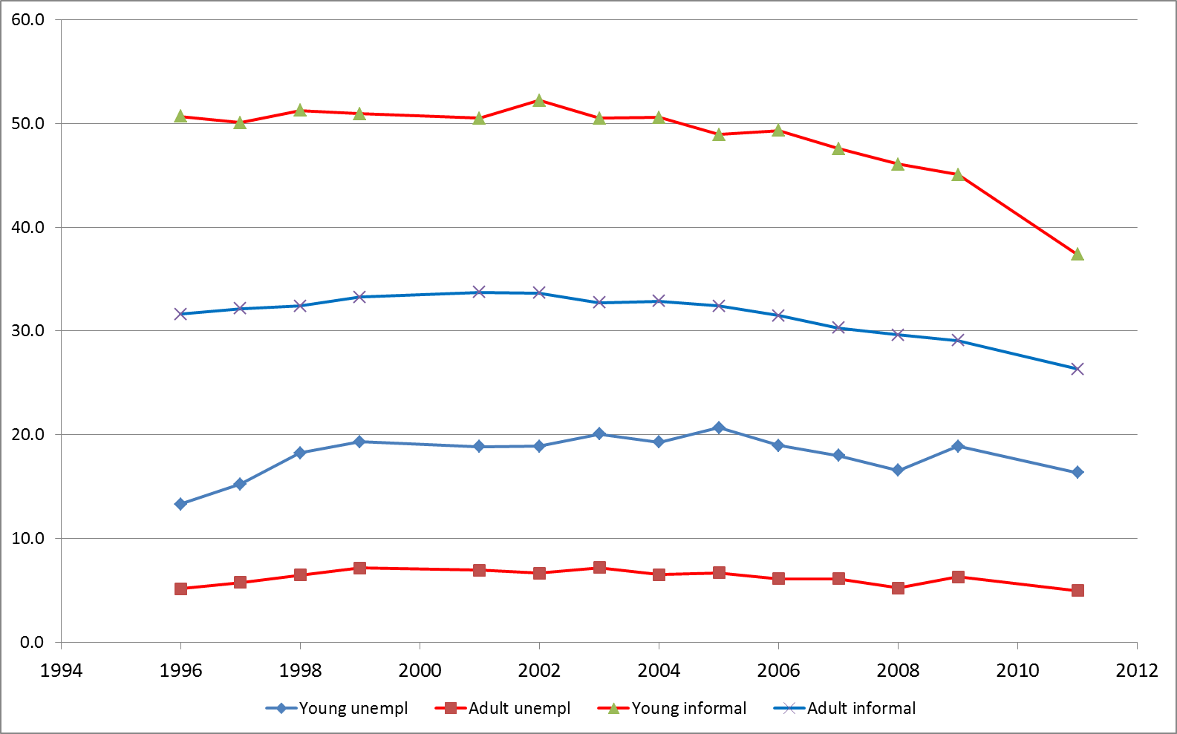
Source: Authors´ estimates based on PNAD/IBGE data. The nationally representative survey is not carried out in Census years (2000 and 2010).

In sum, the Brazilian labor market does seem to follow the general trend documented for other developing countries of both higher unemployment and informality rates for youths than for adults.

3. Worker flows: the contrast between young and adult workers
3.1. Basic Measures and Data
Our main data source comes from a Brazilian administrative database (Relação Anual de Informações Sociais - RAIS) which is maintained by the Brazilian Ministry of Employment and Labor (Ministério do Trabalho e Emprego – MTE). In Brazil, all registered, tax-paying establishments must send information to the Ministry regarding all employees who worked anytime during the reference year.
RAIS provides matched employer-employee longitudinal data similar to those available in developed countries. The data include worker specific information (such as gender, age and schooling), establishments (such as location and industry), and contract information (such as contracted wages, working hours, types of contract, hiring and separation dates, and reasons for separation). In our analysis we make intensive use of the last set of variables.
Our results rely on information on hirings and separations between 1996 and 2010 to compute traditional measures of worker flows, adapted to the context of age specific groups. We calculate the hiring and separation rates for age group a in year t as: H_{at}= Σ_{i} h_{iat}/X_{at} and S_{at}=Σ_{i} s_{iat}/X_{at}, respectively, where i represents establishments, h_{iat} is the number of hires of workers of age group a over the course of the year t, s_{iat} is the number of separations for age group a over the year t at establishment i, and X_{at} is the aggregate average (between 31/12/t and 31/12/t-1) employment level of the group of workers under consideration.
These two rates can be combined to provide evidence on turnover. First, we aggregate the overall amount of worker flows using the worker turnover rate: T_{at}= H_{at} + S_{at}. The more heterogeneous is the workers’ flow profile within firm × age cell, the higher is the distance between turnover and any of its components. Following this insight, another interesting measure is the churning rate, which is defined as CH_{at}= T_{at} – |NET_{at}|, where NET stands for net employment growth.
The context of age specific groups matter to the way labor flow measures are computed. In the traditional analysis at the firm level, NET could be either computed as:
NET_{t}= H_{t} – S_{t}, (1)
or as:
NET_{t}=Σ_{i} Δn_{it}/X_{t}.
However when dealing with age specific groups, the two measures differ from each other due to individuals crossing the threshold that divides adjacent age groups while continuously employed in the same business unit i. These individuals do contribute to age group specific employment stock variation (Δn), but do not contribute neither to hiring (H) nor separation (S) rates. Hence we will rely on the first procedure and compute NET as in expression (1).

3.2 Youth Labor Market Trends based on flow measures
The striking differences between flows measures of young and adult workers are summarized in a single graph (Figure 2), where we plot H (vertical axis) and S (horizontal axis), elaborating on Burgess et al. (2001). There are large difference in these flow measures between the two groups, with both hiring and separations rates higher for youths. This implies that the turnover rate for young workers overtakes that for adult workers.
Figure 2 also shows a higher net employment rate for young workers. Points along the 45º line corresponds to NET=0, as H=S. The scatter points for adult workers are either around or a little above the 45º line, a pattern which evinces a small, positive average net employment growth for this group in the period of analysis. Net employment growth increases northwest with respect to the 45º line. ‘IsoNET’ lines are also plotted in Figure 2, indicating the different combinations of H and S that yield 10, 20, and 30% net employment growth rates. Differently from the adults’ pattern, the net growth rates for young workers tend be spread along the 20% IsoNet line. This shows that, on average, youths experience a much higher employment growth rate than adults in the formal labor market in Brazil. Figure 3 confirms that and shows that the growth rates have exhibited a slight increasing trend for both groups over the period of analysis.

Figure 2: Hiring and separation rates by age group, 1996-2010
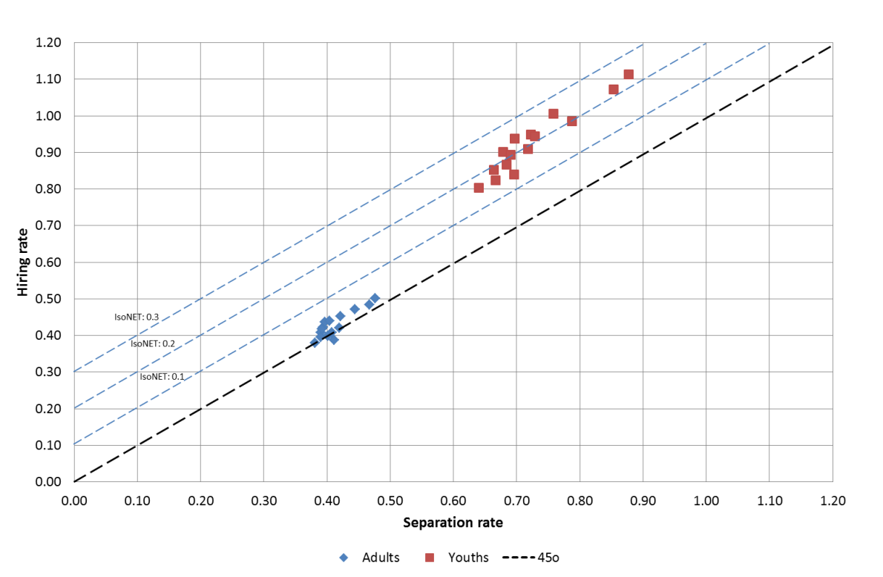
Source: Authors’ calculations based on RAIS/MTE data.

Table 1 summarizes the time series of each group flow indicators. The Table initially reports the average value for the hiring rate (H), the separation rate (S), and the turnover rates (T and CH) for both age groups for the period 1996-2010. From Figure 2 we knew that both the hiring and separation rates were higher for younger workers. Table 1 brings the magnitude of such difference. The first striking result is that the average hiring rate for youths (92.6%) is more than two times higher than the average hiring rate for adults (42.8%). This indicates that Brazilian youths do not seem to face problems to get jobs in the formal labor market in the country. The difference in separation is a little less pronounced but still of considerable magnitude. Indeed, the figure for youths is as high as 72.4%, while it amounts to 41.3% for the older group (1.8 ratio).

Figure 3: Net employment growth rate by age group, 1996-2010
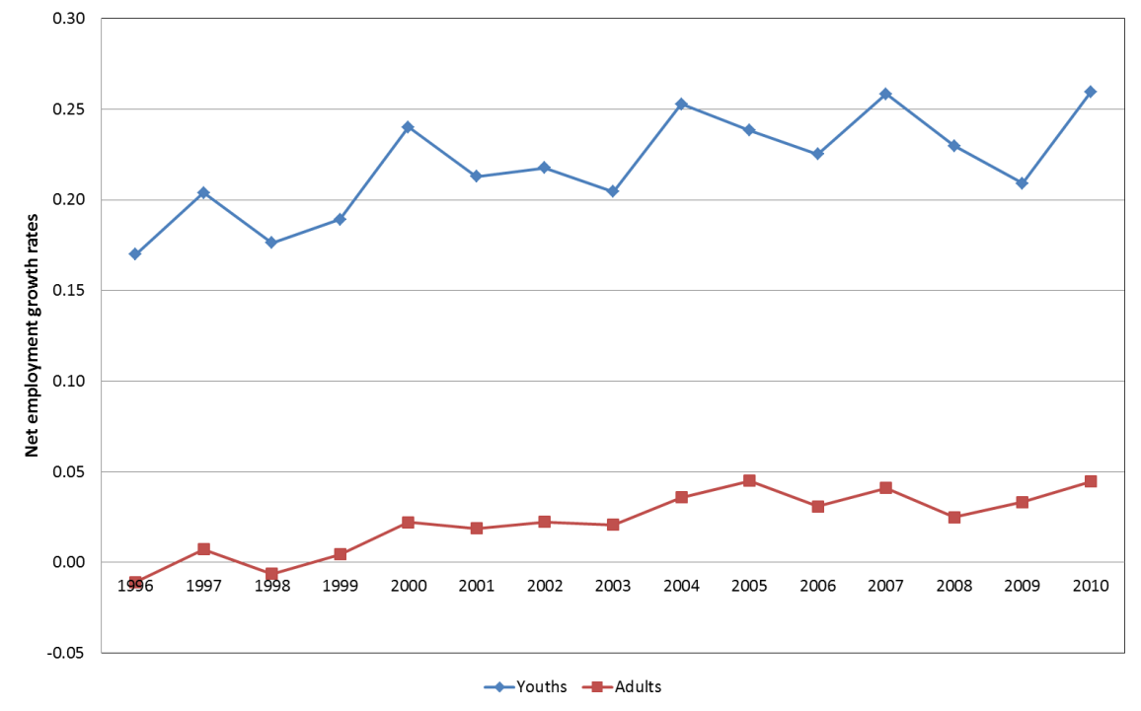
Source: Authors’ calculations based on RAIS/MTE data.

The comparison of turnover rates adds these two differences and provides the second striking result. Turnover rates reach the impressive value of 165.1% for young workers and 84.1% for adults. The rate of 1.65 for youths means that there are more than eight younger worker transitions into and from formal employment for each five employed young workers, on average, each year. Even the adult turnover rate is very high for international standards (see, e.g., Davis and Haltiwanger, 1999 and Corseuil and Santos, 2006). Given the behavior of net employment growth rates mentioned above, the churning rate for youngsters decreases more than that for adults (with respect to the turnover rates), but the ratio between the two churning rates is still around 2.
From Figure 2 we can see that the hiring and separation rates for young workers are more disperse over time than the corresponding ones for adults. In order to take that into account, we calculated the coefficients of variation (CV), which are also presented in Table 1. The interesting finding brought by the CV calculation is the reversal of the order of the comparison of the hiring and separation rates between the two groups. Indeed, when the dispersion in the rates is incorporated, the differences between the groups become higher for separations (CV of 0.095 for youths and 0.069 for adults, ratio of 1.4) than for hirings (CV of 0.096 for youths and 0.084 for adults, ratio 1.1). One possible interpretation for this is that young workers flows, particularly hiring rates, are relatively more affected by the business cycle.

Table 1: Summary of flow indicators by age group, 1996-2010
 | H | S | T | CH
Youths
Average | 0.926 | 0.724 | 1.651 | 1.448
CV | 0.096 | 0.095 | 0.094 | 0.137
CORR GDP | 0.708 | 0.563 | 0.652 | 0.563
Adults
Average | 0.428 | 0.413 | 0.841 | 0.823
CV | 0.084 | 0.069 | 0.074 | 0.059
CORR GDP | 0.555 | 0.405 | 0.505 | 0.429
Ratio Youth/Adults
Average | 2.2 | 1.8 | 2.0 | 1.8
CV | 1.1 | 1.4 | 1.3 | 2.3
CORR GDP | 1.3 | 1.4 | 1.3 | 1.3
Source: Authors’ calculations based on RAIS/MTE data. H: Hiring rate; S: Separation rate; T = Turnover rate (T=H+S); CH= T - |H-S|. CV is the coefficient of variation. Corr GDP represents the simple correlation of each variable with GDP.

Table 1 allows us to check how close is the association between the business cycle and the age-specific labor flows. The rows Corr GDP in the Table display the correlation coefficient between each flow measure and the GDP. The correlations confirm that the flow measures for young workers are more sensitive to business cycle than the ones computed for adult workers (correlations for the former group are around 30 to 40% higher than that of the latter group).
The results presented in this section indicate that young workers do not seem to face strong barriers to formal labor market entry in Brazil. The lowest value of the hiring rate was 80%, its average amounted to more than 90%, and in three years (2007, 2008, and 2010) it surpassed 100%. But, though jobs are relatively easy to get, they are also riskier to lose. Indeed, the figures show that separations rates are also very high for youths: minimum of 65%, average of more than 70%, and in two years (2008 and 2010) it was above 85%. As a result, young workers end up experiencing very high levels of labor market turnover. On the one hand transiting across many different jobs may enhance better matching with firms. On the other hand, entering and leaving jobs very easily tend to depress the acquisition of general and firm-specific labor experience. Since the accumulation of this type of human capital is important, the elevated turnover experienced by youths in Brazil is a factor that hinders the increase in their (future) productivity and wages.

4. A closer look at youth hiring rates: the role of unstable jobs
Hirings and separations from jobs are not necessarily independent events. For instance, in a developing country like Brazil, there is a large share of jobs of inferior quality (low wages, temporary contracts, unsatisfactory working conditions etc.) which are easily filled by the large share of less qualified workers available in the country. As they do not retain workers for long periods, high levels of hirings and separations are a common feature of this kind of jobs. If youths’ hirings are overrepresented in this type of jobs, then at least part of the high levels of separations we observe for them comes from the high levels of hiring to unstable jobs. In order words, high separation rates could be induced by entrance “through the wrong door”.
In order to investigate this possibility, we explore some features available in our data to check whether or not younger workers are overrepresented in some types of jobs that tend to have higher degree of instability. Specifically, we will look at the proportion of temporary jobs or jobs at cooperatives in hiring episodes involving young workers.
Figure 4 shows the share of hirings in temporary contracts for young and adult workers. Two points stand out from this Figure. First, the share of temporary contracts is much lower in Brazil than what is reported for EU countries: while the share for Brazilian young workers never reached 13% between 1996 and 2010, the figure is close to 43% in the case of EU countries (O’Higgins, 2012). Second, despite the similar values at the beginning of the period, the share of youths hired for temporary jobs rose, while the corresponding share for adults did not change much. In part, the rise observed for youths can be attributed to the increased use of the apprentice contract, which was launched by the government in 2000.
Another form of unstable jobs often pointed as partly responsible for downgrading labor relations in the country are jobs offered by cooperatives (“coops”). Figure 5 shows the share of youths and adults that were hired by cooperatives between 1996 and 2010. The main point to notice from this Figure is that the fraction of the age groups hired by coops during this interval was less than 1%, that is, almost a negligible fraction. Coops do not seem to contribute to inflate neither the hiring nor the separation rates of young workers.

Figure 4: Share of hirings in temporary contracts by age group, 1996-2010
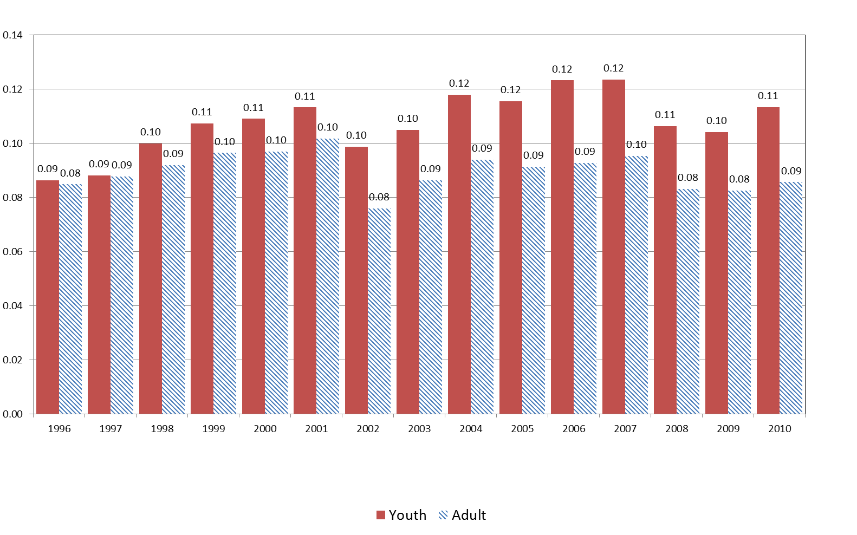
Source: Authors’ calculations based on RAIS/MTE data.
In summary, the evidence presented in this section shows that the pattern of hirings of young workers either in temporary contracts or cooperatives does not seem to be responsible for the relative higher separation rate observed for this group. Further investigation seems necessary to check whether this connection from higher hiring to higher separation in fact exists and, if so, how it operates, especially for young workers. We focus on separation rates themselves in the next section.

Figure 5: Share of hirings by cooperatives by age group, 1996-2010
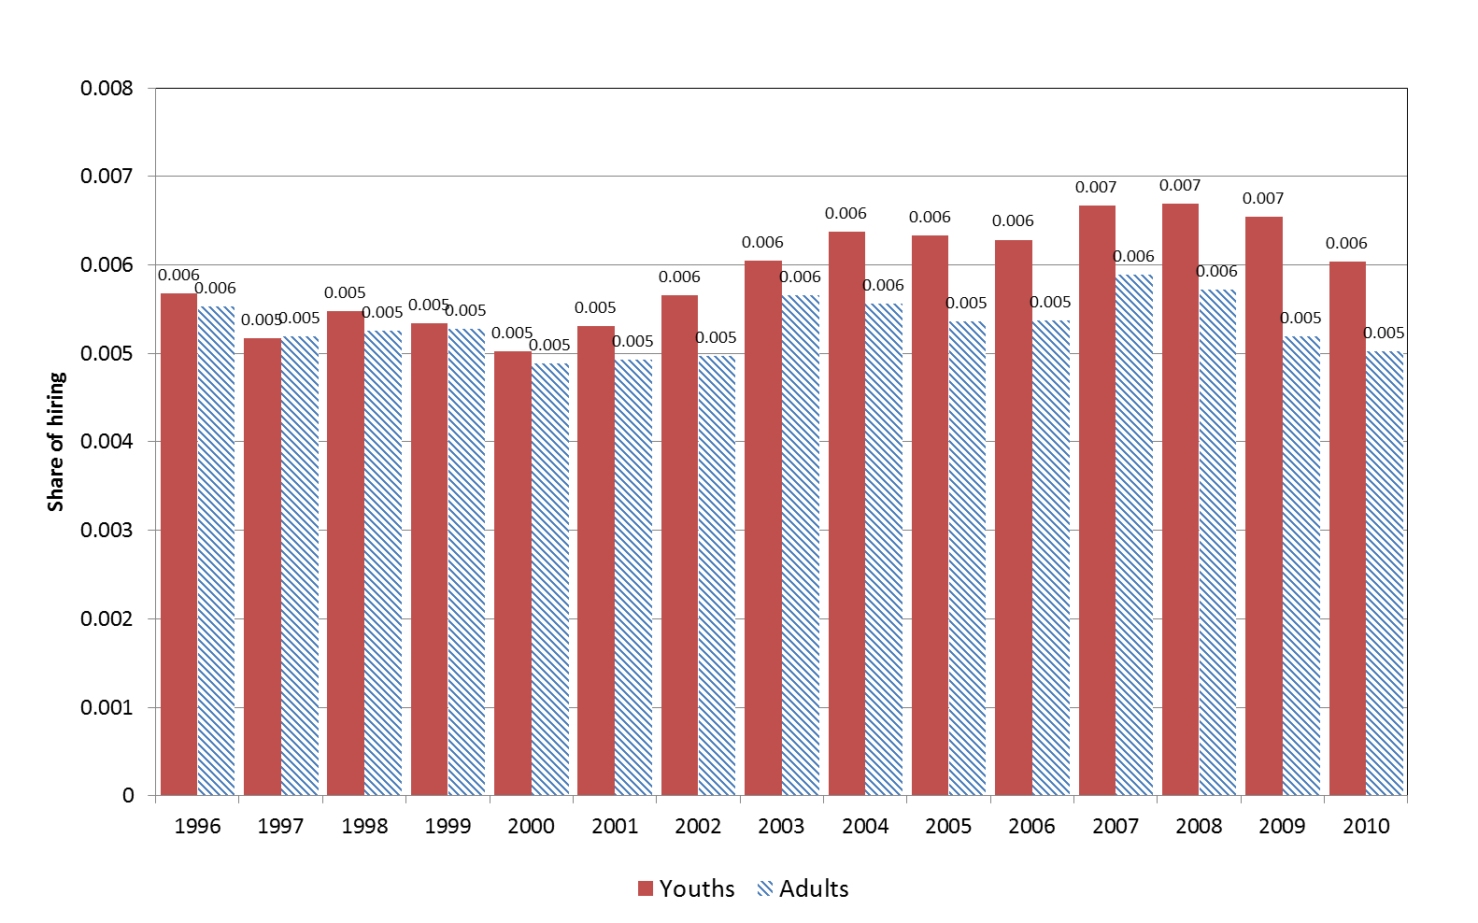
Source: Authors’ calculations based on RAIS/MTE data.

5. Looking for the determinants of higher separation rates for youths
In this section, we look deeper at the separation rate for young workers. Our data allow us to investigate three important dimensions of separations. First, we distinguish between what we call permanent and transitory separations. Second, we see whether separations are relatively more motivated by one of three reasons: the voluntary decision of the worker to quit the job, the decision of employers to lay-off the worker, or the simple expiration of a temporary contract. Third, we try to look at whether separations of young workers from their jobs result in a job destruction or the substitution of the young worker for an adult or another young worker.
5.1. Permanent versus transitory separations
Our first distinction is between permanent and transitory separations. It is argued that the Brazilian labor legislation induces fake lay-offs. When this happens, data register a hiring and a separation of the same worker by the same firm within a certain period of time. In order to minimize the effect of this “double” counting, we define the permanent separation rate for age group a as: S^{p}_{at}=Σ_{i}s^{p}_{it}/X_{at}, where s^{p}_{it} is the number of separations that were not reverted at firm i during year t. The transitory separation rate can then be defined as: S^{t}_{at}=S_{at}- S^{p}_{at}, where S_{at} is the (gross) separation rate for age group a in year t.
Figure 6: Permanent and temporary separation rates by age group, 1996-2010.
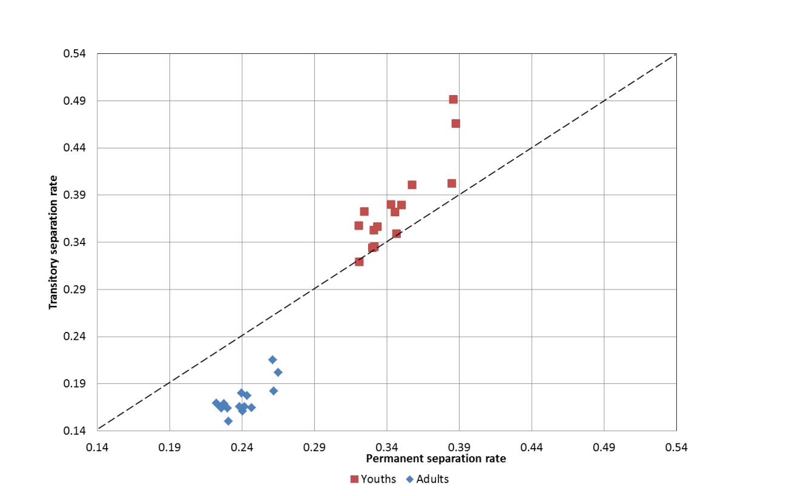
Source: Authors’ estimates based on RAIS/MTE data.

Figure 6 displays the figures for the two types of separations for youths and adults. As it can be seen, both rates are higher for the younger group but the permanent rate is relatively higher for adults (it represents on average almost 3/5 of all separations) than for youths (account for around half of all separations on average). While transitory separations do increase turnover rates, the sheer magnitude of permanent separations rates of about 34% (always larger than 30%) confirm the volatile attachment of younger workers, compared to older workers. Permanent separations for adult workers are lower, at about 24% and never higher than 28%.
In order to analyze in a more structural fashion the differences in separations between our groups of interest, the rest of this section will be based on the measure of permanent separation.

5.2. Quits versus layoffs
Figure 7 shows that lay-offs are the most important reason for separations for both age groups. The Figure also shows that, though they have lost some importance over time for both groups, lay-offs are more relevant as a cause of separation for adults than for young workers. In fact, this difference has doubled over the years, rising from 6 p.p. in 1996 to 12 p.p. in 2010. The decline in the share of lay-offs was initially compensated by an increase in the contribution of expiration of temporary contracts but towards the end of the period there was a rise in the share of voluntary quits. It is worth observing that the termination of temporary contracts and quits are more relevant for youths than for adults and these differences have increased over time between the groups.
A set of factors can explain what we observe in Figure 7. First, as temporary contracts are relatively more relevant as a means to hire youth labor (see Figure 4), it is not surprising that separations due to the expiration of this type of contract are relatively more important for this group. Also, in the last two decades, labor legislation encouraged the use of more flexible forms of contracts (e.g. temporary jobs, part-time jobs, and temporary lay-offs) in many countries. This has not been different in Brazil, a fact that can explain the increase in this form of separation at least in the first part of our period of analysis.

Figure 7: Share of Separations by Proposer, 1996-2010
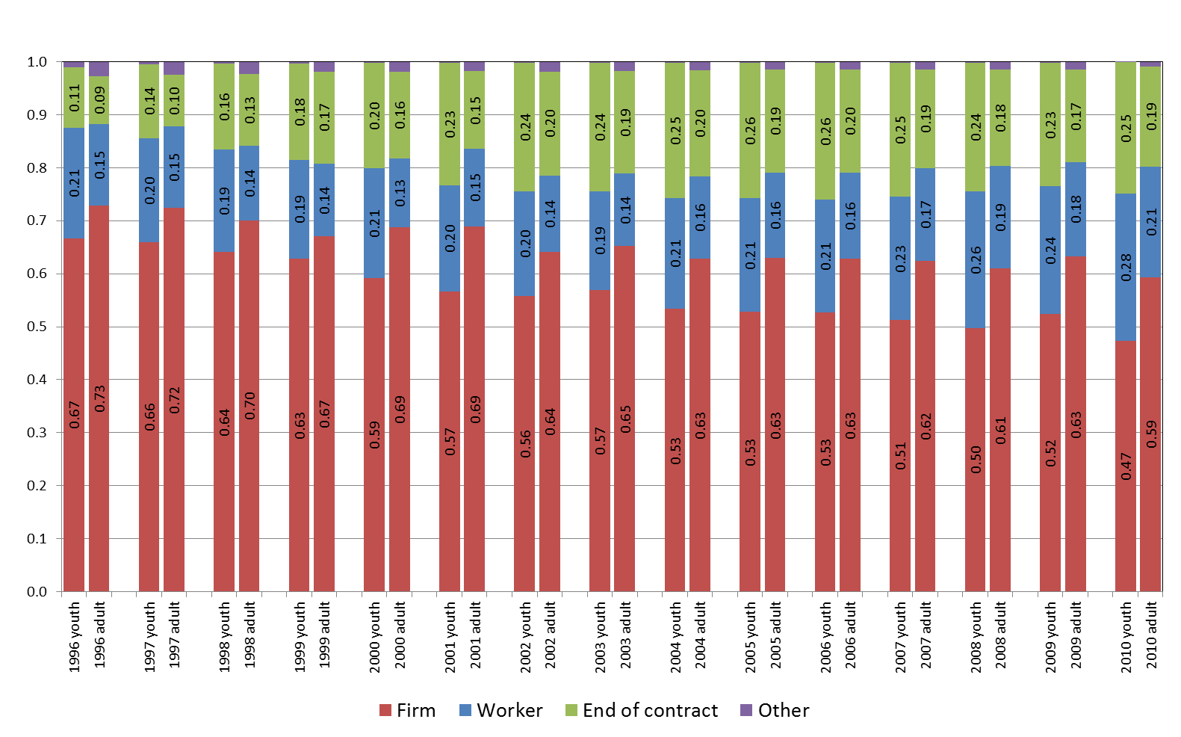
Source: Authors’ estimates based on RAIS/MTE data.

Another factor is associated with the labor supply behavior of youths, who tend to “shop” jobs around more than adults. This can explain why quitting is more prevalent among the former group. In addition, as workers respond to the prevailing economic conditions, the supply side can also explain why we observe increases in the contribution of voluntary leaving for both types of workers in years of economic expansion. Firms may also have different sensitivities to dismissing adult and young workers over the economic cycle. We saw evidence of that in section 3, so at least part of the rise in the difference between the groups in the contribution of lay-offs may be attributed to the distinct response of firms to the last economic cycle in Brazil.
5.3. Job destruction versus worker substitution
This subsection is based on a decomposition of separation rates. First, when a separation occurs it can ensue what we term effective job destruction, when the firm terminates position. Second, when a substitution does take place, the worker can be replaced by another worker of same age (within substitution) or by a worker from a different age group (between substitution). We will decompose the separation rate in these three categories.
Let JD_{at}= Σ_{i} Δn_{iat}I(Δn_{iat}<0)/X_{at} be the job destruction rate for age group a, where i represents firms, t the year, and I(.) is the indicator function that assumes value one when its argument is true and zero otherwise. Similarly, let JC_{at}= Σ_{i} Δn_{iat}I(Δn_{iat}>0)/X_{at} be the job creation rate for age group a in year t.
We define the within age-group substitution rate as the difference between the permanent separation rate and the job destruction rate for age group a: W_{at} = S^{p}_{at} – JD_{at}. The between age-group substitution rate is defined as: B_{at} = min{JC_{a’t} * x_{a’,a}; JD_{at}}, where a’ denotes a different age group from a and x_{a’,a} = X_{a’t}/ X_{at}. Finally, we can define what we call the effective job destruction rate for group a at time t: EJD_{at} = JD_{at} - B_{at}. The interpretation of these concepts is that from all separations that occurred for age group a in the economy, part resulted in the substitution of workers from the same age group, part in the substitution of workers from another age group and the rest is attributed to what would be the effective destruction of the job occupied by workers of group a.
Perhaps the most interesting result revealed by Figure 8 is the low degree of substitution between youths and adults. Indeed, the share of substitution of one type of worker for the other is on average 4% and never surpasses the 5% level over the entire period of analysis. Though a more in-depth analysis would be needed, these low figures give an indication that young and adult labor enter the aggregate production function almost in a fixed proportion fashion. Figure 8 also reveals that substitution within the same age category is more common for youths than for adults, with a difference in shares of around 6 p.p. for the former group. It is also noticeable that replacement within the same age group became more important across the years for both groups. Indeed, there was a rise of more than 10 p.p. for youths and adults when we compare the share of within substitution in last half of the 1990’s with the last half of the 2000’s. The opposite movement happened with the share of separations due to job destruction. Again, part of this may be explained by the response of workers and firms to the economic cycle.
Figure 8: Share of Separations by Type: Job Destruction and Substitution Within or Between Age Groups, 1996-2010
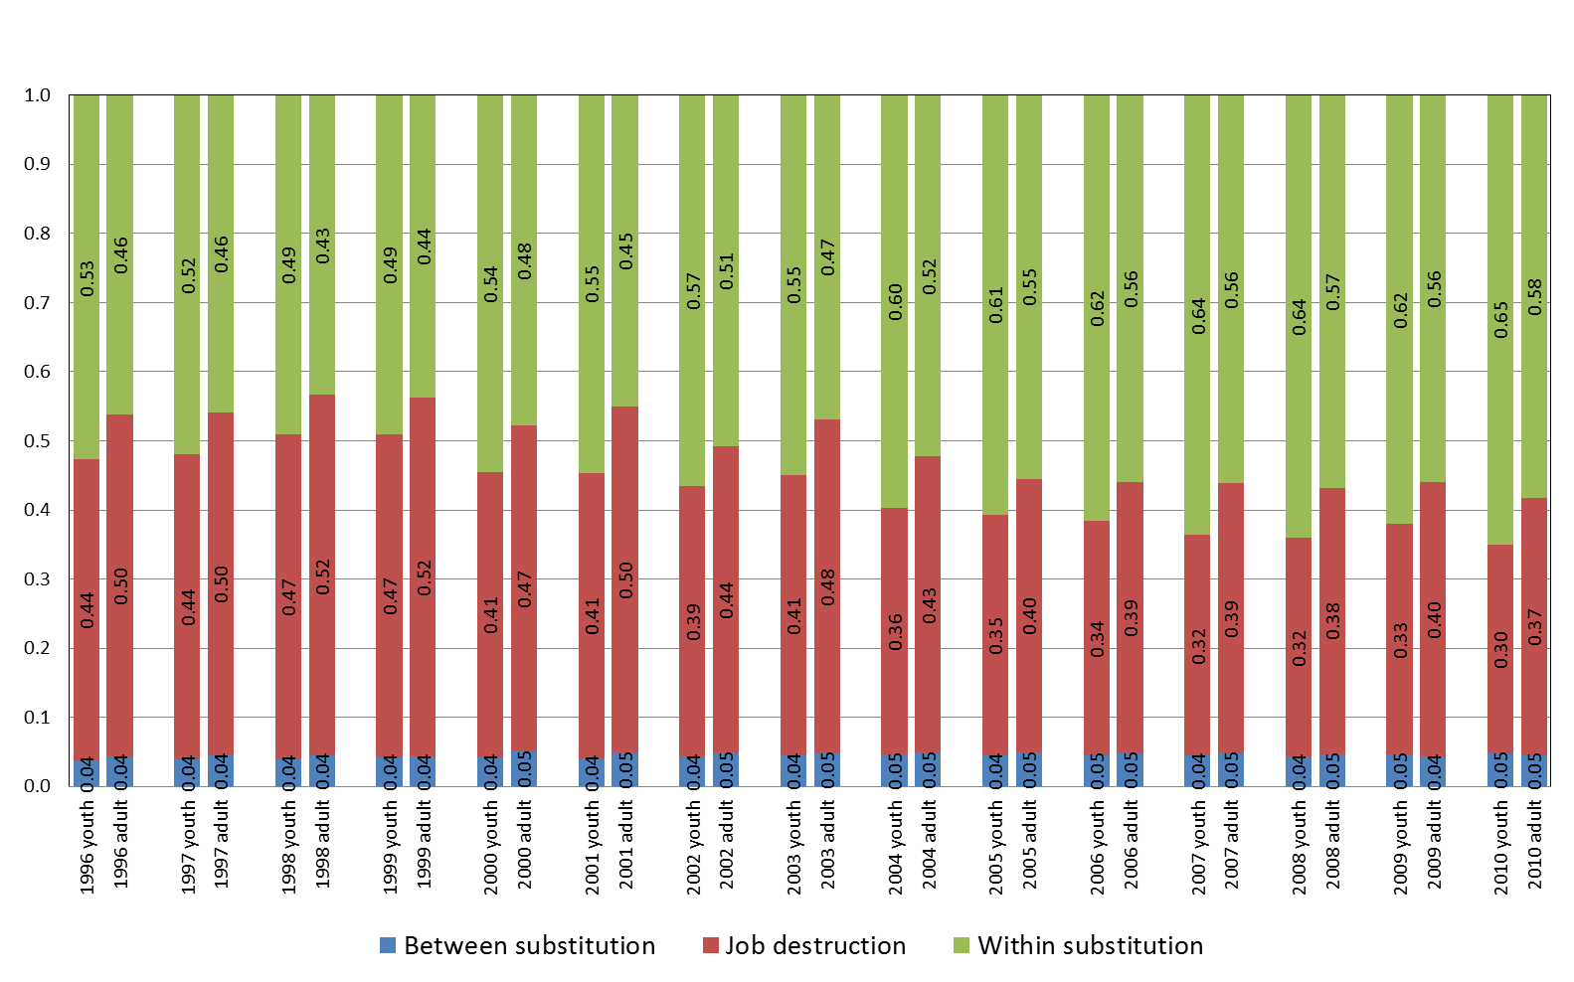
Source: Authors’ estimates based on RAIS/MTE data.

In sum, the evidence presented in this section shows that: permanent separations are an important fraction of separations for youths, voluntary quits and the termination of time-limited contracts are relatively more relevant for youths than for adults, and the main form of replacement of youths is not a substitution by an adult but a substitution by another worker of the same age group. Another important result is that job separations (particularly lay-offs and job destruction) for both age groups seem to be affected by the business cycle. Although a deeper investigation would be needed to reach a clearer understanding of these findings, it is quite likely that demand, supply, and institutional factors, played their role in explaining the turnover patters in the last 15 years.

6. The effects of workers’ age on turnover
One conclusion that emerges from the previous section is that young and adult workers may enter the production function in a fixed proportion fashion. That is to say that some jobs may be allocated only for young workers. Assume that the turnover rates for these jobs were intrinsically higher. If so, the higher turnover rates observed for young workers may be a consequence of their allocation to high turnover jobs. For instance, young workers may be allocated to high turnover industries, like construction or retail trade. Figure 9 below confirms that there are sharp differences in turnover or churning rates across industries in our data.
Figure 9 - Labor churning and youth employment share by industry
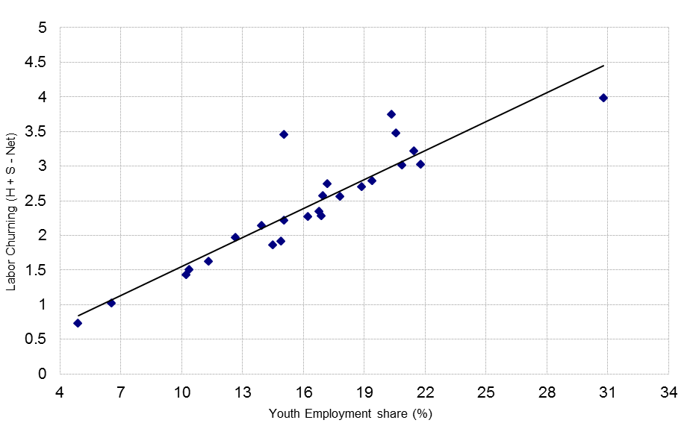
Source: Authors’ estimates based on RAIS/MTE data.
In Figure 9 each point corresponds to an industry. The line represents the linear correlation between the average turnover (measured by labor churning) and the average share of young workers across industries between 1998 and 2010. The Figure clearly shows that establishments in high turnover sectors tend to employ a higher share of young workers. Therefore the high turnover computed for young workers may be, at least in part, due to the allocation of this group across industries. The main goal of this section is to go one step further towards the identification of a direct effect of age on turnover.
6.1. Variance Decomposition
The argument developed above may be generalized to other establishments’ observable characteristics. In order to expand the analysis to a multi-dimensional approach, we first perform a traditional within-between variance decomposition. Worker and job flow metrics are calculated for cells defined by a combination of the following characteristics: industry, workers’ age, establishments’ age, establishment size and year. These measures are then regressed against a series of dummies for the characteristics according to the following model.
Y_{a,j,k,m,t} = α_{a} + β _{j} + δ _{k} + θ _{m} + λ _{t} + ε_{a,j,k,m,t},
where Y_{a,j,k,m,t} represents a measure of either job or worker flow computed for the cell defined for worker of age “a”, industry “j”, plant age “k”, size “m”, and year “t”. In the right hand side we have the terms capturing the effects of each of these variables, plus a cell idiosyncratic non-observable component.
Table 2 below presents the variance decomposition results for each job and worker flow measure. The Table reports the explanatory power of each characteristic, measured as the characteristic mean square divided by the regression mean square. We use mean squares instead of just squares in order to control for the higher explanatory power of characteristics with more degrees of freedom. Characteristics that explain twice the regression mean square are highlighted in gray.

Table 2 – Worker flow metrics within- and between-characteristics variance decomposition
 | Year | Worker age | Firm size | Firm age | Sector
NET | 0,48 | 10,32 | 0,09 | 10,38 | 0,03
H | 0,58 | 8,34 | 0,18 | 9,84 | 0,17
S | 0,18 | 7,78 | 0,13 | 2,21 | 0,88
T | 0,61 | 5,49 | 0,29 | 7,01 | 0,56
CH | 0,10 | 10,64 | 0,23 | 0,59 | 0,68
d_firma | 0,86 | 6,93 | 0,57 | 0,23 | 0,54
df | 14 | 3 | 7 | 1 | 25
Source: Authors calculations based on RAIS/MTE data. H = Hiring rate; S = Separation rate; T = Turnover rate (T=H+S); NET=Net Employment Growth (NET=H-S); Churning rate (CH=T – |NET|)). Df – characteristic degrees of freedom (number of categories minus one). Cells measure the ratio between the characteristic mean square and the explained mean squares. Characteristics mean squares are measured comparing residual sum of squares with and without the variable group (Anova decomposition). Gray cells indicate characteristics with twice the regression mean square.

The results indicate that the workers age generate the sharpest difference across cell flow measures. Other characteristics are relevant (and significant), but with smaller explanatory power. Business unit age seems more important than industry and firm size. Business cycle variation has relatively small explanatory power, a result that contrast with one of the stylized facts in the literature, namely the dominant role of business cycle to explain youth unemployment. Therefore, there seems to be an important role for cell idiosyncratic non-observable characteristics in explaining job and worker flow. This is further explored in the next section.

6.2. Estimation of hazard models
The decomposition above can be considered an illustrative first step in trying to isolate the intrinsic contribution of age to turnover. But the challenging identification problem remains as the results on the previous section cannot be used “prima facie” to address this question. The reason is that age may be associated either to individual characteristics or unobservable job characteristics. For instance, it has been previously shown in the literature that young workers accumulate less human capital, a finding that can be associated with high turnover.
An ideal setting to tackle this issue is to analyze longitudinal worker level data that carries information on the establishment that hosts his job. At this level, we can analyze the determinants of employment duration considering both individual and job characteristics.
The standard econometric procedure to study duration events is the estimation of hazard models. Our previous discussion suggests that such estimation should be able to take into account idiosyncratic characteristics on top of observable characteristics. We chose to use the following proportional hazard model specification with fixed effects:
h_{ij}(t) = α.D_{ij} + β.X_{ij} + γ_{j} (t) , (2)
where h_{ij}(t) denotes the logarithm of the hazard rate of worker i completing her employment spell at establishment j at a length t. D_{ij} are workers age-group dummies, and X_{ij} are observable characteristics of workers and establishments (to be detailed below). These variables are measured at the start of the corresponding employment spell. The term γ_{j}(.) is the baseline hazard function of the employment spells. As we use a Cox version of the proportional likelihood estimator, there is no need to specify any parametric form for the baseline hazard.
The key departure of our specification from conventional proportional hazard models is to allow variations of the baseline hazard across establishments. This takes into account any non-observable specificity at the firm level that may affect the hazards of its employees, even if such specificity is also correlated with any other observable characteristic. This strategy enhances the credibility of our identification strategy as does the inclusion of a fixed effect term in conventional regression models with panel data. As mentioned before, workers with similar observable characteristics could have different separation rates because of heterogeneity across firms in unobservable characteristics (like manager tolerance with either worker performance or behavior in the workplace). Allowing establishment idiosyncratic effects as specific baseline hazard rates allows us to compare workers that are in the same establishment (and therefore subject to the same idiosyncratic factors). This information is delivered by the parameter α, which informs how the hazard rates vary among similar workers in the same firm by age group.
As pointed out by Chamberlain (1985) we can use partial likelihood (PL) methods to get rid of γ_{j}(.) and estimate the model without further complications. Allison (1996) shows that such estimator, which he refers as fixed-effect partial likelihood, performs very well with simulated data despite Chamberlain’s concerns with the validity of one assumption for PL methods in the context of duration models.
For the analysis of hazard rates, we use all episodes of hirings that took place in the period from 1996 to 1998. We measure the employment spell following the worker-establishment match until one of three restrictions occurs: i) the match is broken and the establishment keeps employing other workers, ii) the establishment leaves the market (or at least disappears from RAIS), and iii) the match survives until the last year of our data (2010). If the match faces one of the two last restrictions we classified the employment spell as a censored one.
As in other applications using RAIS data, we apply some filters. First, we eliminate separation episodes that resulted from individual death or retirement. We also exclude from the analysis employment spells that satisfy, at the initial point, at least one of the following conditions: worker aged 55 or older, in agriculture, in the public sector, or under a temporary contract. These procedures leave our sample with 27,162,416 employment spells. For each employment spell we collected information on workers age, gender, schooling level, and contractual number of hours.
In order to get more intuition from the results, we present two alternative specifications for the hazard model: the first includes plant fixed effects and the other does not. Table 3 below presents the results. The first three rows report the results for the effect of distinct age categories on the hazard rate relative to the base age category of over 30 years old. The first thing to notice is that the dummies for young ages (14 to 17 and 18 to 23 years old) are associated with positive and significant coefficients, in both specifications. This confirms that hazard rates are higher for young workers. However it is interesting to point the non-monotonic effect of workers age on the hazard rate. Late young workers (18 to 23) are associated with the highest hazard, irrespective of the model specification.

Table 3: Hazard estimations for the separation of a worker from the current employer
Note:
Very low education: First half of primary education
Low education: Second half of primary education (but not complete)
Medium education: Completed primary education or incomplete secondary education
Part-time: Work 30 hours or less per week
Basel categories: women older than 30 years, highly educated that was hired in 1998.

Also interesting is the comparison across specifications of the estimated values of the coefficients for the first two age categories. The introduction of establishment fixed effects has similar impacts on the estimated coefficients of these two age categories. The effect for the 14 to 17 years of age group (relative to the base category of older than 30) decreases from 0.135 to 0.068 as we add establishment fixed effects. This 0.07 difference between the two specifications, almost doubling the coefficient, represent around half the initial estimate and it is also observed for the 18 to 23 category, for which it represents around 45% of the initial estimate. This common pattern suggests that both “teen” (14 to 17) and late young workers (18 to 23) tend to be allocated in high turnover establishments, relative to older workers.
The remaining rows in Table 3 report the estimated coefficients of the control variables in each one of the two specifications. An analysis of the estimated values for these coefficients can be grouped into three categories according to how the effect changes across model specifications. Firstly, the effect of education is also reduced once we add establishment fixed effects. In fact, the magnitude of this reduction is even higher than the one registered for age. We should point out however that, despite this reduction, the magnitude of the effect of education is still very high. Moreover, as it can be seen, the lower the education level of the worker, the higher the impact on turnover. Secondly, the effect of gender is stable across model specifications. Finally, the effect of working under a part-time contract not only increases once we add establishment fixed effects, as it flips sign, becoming positive.

7. Concluding comments
Using a rich employer-employee dataset we were able to draw an overall picture of how youths have performed in the formal labor market in Brazil in a recent period of 15 years. Based on the flow approach, we show that both the hiring and the separation rate for this group are quite high both in absolute and relative terms. The average figures for the hiring and separation rates for youths are over 90% and 70%, respectively, leading to an impressive turnover rate of more than 160%, twice the value observed for adults. Though it may induce better matching with firms, such a high level of turnover tends to hamper the accumulation of firm-specific experience, which can be an important form of human capital. A lower level of productivity can result, producing negative impacts at both the individual and the aggregate levels.
We look deeper at each component of the turnover rate. Potentially, an elevated hiring rate has both a positive and a negative side. On the one hand, it makes it easier for youths to get a job but, on the other, it generates less incentive to keep them. This last force induces job separations and therefore diminishes the duration of employment. In addition, if youth hirings are concentrated in unstable jobs, even higher levels of separations are expected. Our initial empirical investigation of the connection from hirings to separations was able to find some evidence that youths do not seem to be particularly allocated to more unstable jobs (temporary contracts or cooperative jobs).
Looking at job separations patterns, we found that quits are more prevalent among young workers than among adults. As mentioned, this can be associated with the high hiring rates of the former group. But it can also be associated with the supply behavior of youths, which typically involves more “shopping” across jobs in the labor market. We also found evidence that separations due to the expiration of temporary contracts are relatively more important for youths than for adults. The results also show that this cause of separations increased for both groups during the 2000’s, a phenomenon that may have to do with the introduction of incentives to use more flexible forms of labor contracts. Finally, we also found that a considerable fraction of separations do not end up in job destruction but rather in the replacement of one worker for another. In particular, the results evince that the more prevalent form of substitution is not across workers of different age groups but between workers of the same group.
Going one step further, we investigated to which extent one can say that the high turnover measures for youths can be attributed to their younger age. In other words, we conducted some exercises to isolate the contribution of the workers’ age from that of other factors. This was carried out through two exercises. The first was a statistical model that tried to separate out the relative importance of age to explain the variation observed in various flow measures we used throughout the paper. The second was an econometric model of duration that tried to isolate the contribution of age on the duration of employment. Establishments’ unobserved characteristics were incorporated in this last model. The results from both types of models show that to some extent the age of the worker contributes to explain the higher turnover rates and the lower employment duration observed for younger workers.
Condensing these results for policy purposes, the main empirical result is that young workers experience very high rates of turnover in Brazil due to both hiring and separation rates. In order to make the turnover rate decline, the main margin of policy attention should be the separation rate. Indeed, though hirings and separations are interrelated, tackling the problem of high levels of separations looks more efficient in the sense it directly attempts to keep workers longer in their jobs. The high hiring rates does not credence a lack of jobs for youth. Rather, the high separation rates imply short lived unstable jobs.
One must firstly recognize that other factors apart from the age of individuals operate. In particular, as the results of section 6 show, the education of workers seems to be an important factor to decrease turnover. In this sense, the more the education policy accelerates the increase in the schooling level of the new cohorts of workers, the lower should be the turnover expected for them.
Labor market policies should also be part of the strategy to lower the separation rate. Probably, job search assistance initiatives cannot do much, unless they are capable of generating worker-firm matchings that produce longer employment durations. Providing wage or tax subsidies for firms to extend the tenure of youths should be thought very carefully in particular because its costs can become very high. One could also devise a system that creates incentives for young workers and firms to increase the value of longer job relationships. Finally, training programs partially funded by the worker and the firm may create incentives for both parties to invest in each other in the longer term.

References
Abowd, J. M. and Kramarz, F., (1999). "The analysis of labor markets using matched employer-employee data" in: O. Ashenfelter & D. Card (ed.), Handbook of Labor Economics, volume 3, chapter 40, pages 2629-2710 Elsevier
Allison, P. (1996) “Fixed-Effects Partial Likelihood for Repeated Events” Sociological Methods & Research, 25(2): 207-222.
Blanchard, O.; Diamond, P. The flow approach to labor market. American Economic Review, Papers and Proceedings, v. 82, p. 354-359, 1992.
Blanchflower, D. and Freeman, R. (2000) Youth Employment and Joblessness in Advanced Countries, Chicago: NBER and University of Chicago Press.
Bell, D. and Blanchflower, D. (2011) “Youth Unemployment in Europe and the United States”, IZA Discussion Paper n. 5673.
Burguess, S., Lane and Stevens (2001), “Churning dynamics: an analysis of hires and separations at the employer level”, Labour Economics, 8(1): 1-14.
Camargo, J.M. (1996): Flexibilidade no Mercado de Trabalho no Brasil, FGV, Rio de Janeiro.
Chamberlain, G. (1985) “Heterogeneity, Ommited Variable Bias, and Duration Dependence” pp.3-38 in Longitudinal Analysis of Labor Market Data, ed. J. Heckman and B. Singer. Cambridge Univ. Press.
Corseuil, C.H. and L.S. Santos (2006) Criação, Destruição e Realocação de Empregos no Brasil. Rio de Janeiro: IPEA.

Corseuil, C. H., Foguel, M. and Gonzaga, G. (2013) “The effects of an apprenticeship program on labor market outcomes of youths in Brazil” REAP working paper 042
Davis, S. and Haltiwanger, J.. Gross job flows, volume 3B of Handbook of Labor Economics. North Holland, 1999. editors Orley Ashenfelter and David Card.
Farber, H. (1998), “Mobility and Stability: The Dynamics of Job Change in Labor Markets”, Working Paper, Industrial Relations Section 400, Princeton.
Flori, P. (2004), “Desemprego de Jovens no Brasil”, mimeo.
Freeman, R. and Wise, D. (1982) The Youth Labor Market Problem: Its nature, causes and consequences. Chicago: NBER and University of Chicago Press.
ILO (2012) Global Employment Trends for Youth 2012. ILO, Geneva.
Leighton, L. and Mincer, J. (1982) “Labor Turnover and Youth Unemployment”, in Freeman and Wise (editors) The Youth Labor Market Problem: Its nature, causes and consequences. Chicago: University of Chicago Press
Maloney, W. (1999) “Does Informality Imply Segmentation in Urban Labor Markets? Evidence from Sectoral Transitions in Mexico”, The World Bank Economic Review 13(2): 275-302.
OECD (2010) “Off to a good start? Jobs for the Youth” available at: http://www.oecd.org/els/emp/46717876.pdf
O’Higgins (2001) Youth Unemployment and Employment Policies: a global perspective. ILO, Geneva.
O’Higgins (2003) “Trends in the youth labor market in Developing and Transition Countries”, World Bank Social Protection Discussion Paper n.0321.
O’Higgins (2012) “This time it’s different? Youth labor markets during ‘The Great’ Recession”. IZA Discussion Paper n. 6434.
Saavedra, J. and Chong (1999) “Structural Reform, Institutions and Earnings: Evidence from the Formal and Informal Sectors in Urban Peru”, The Journal of Development Studies 35(4): 95-116

♦ This paper is part of a joint CEDLAS-IDRC project on “Labour Demand and Job Creation: Empirical Evidence from Firms in Latin American”. The authors acknowledge not only the financial support provided by the project but also the useful comments received in early stages of the paper by project coordinators and by Gary Fields who contributed to the project as a technical advisor. We also acknowledge the research assistance provided by Katcha Poloponsky and Alessandra Brito.
A notable exception is the more prominent role of supply factors in developing countries.
O’Higgins (2001) also argues that analyses based on unemployment are particularly problematic for early ages due to the ambiguous attachment of youths to the education system. Increases in unemployment induced by higher enrolment in schooling could be viewed as a good outcome instead of a bad one.
PNAD is a repeated cross-section with annual frequency, has national coverage and is conducted by the IBGE, the Brazilian Census Bureau.
The absence of tax evaders from the sample prevents us from claiming that the data include information on all Brazilian establishments. Rather, RAIS gathers information on what is typically called the “formal sector”.
See Abowd and Kramarz (1999) for a description of the countries where this type of database was available and for information on how labor economics research has benefited from such databases.
Abstracting from inconsistencies in information provided by firms on stocks and flows.
It is interesting to note that this pattern of formal-sector employment growth based on RAIS is consistent with the patterns for the unemployment rate based on PNAD and described in section 2.2.
Table 9 in Davis and Haltiwanger (1999) reports hiring and separation rates between 20% and 30% for developed countries.
See Corseuil et al. (2013) for an evaluation of the effects of the apprenticeship program on youth labor market outcomes.
Since 1994, cooperatives have been exempted from paying many types of labor taxes. Many argue that this exemption has incentivized the creation of several “fake” cooperatives, i.e. coops that are hired by other firms only because they can “formally” hire workers without paying taxes. While we can identify cooperatives in the data, we cannot distinguish whether or not they behave in this counterfeit way.
One cited example is the situation where the employee negotiates a fake dismissal with the employer so that the worker can receive the unemployment benefit for some months and access the accumulated amount in his/her individual severance payment account (FGTS). See Camargo (1996) for a discussion of the (negative) incentives embodied in the Brazilian labor legislation.
Looking at the correlation coefficient between the share of lay-offs for each group and the GDP growth rate between 1996 and 2010, the estimate for youths is -0.57 and -0.52 for adults. The test of equality of these two estimates cannot be statistically rejected, though.
The inclusion of the ratio x_{a’,a} is for compatibility with the denominator of the other rates.
It may be easily seen that S_{at}=W_{at}+B_{at}+EJD_{at}.
We use three age categories (14-17; 18-23 and 24-60), seven firm size categories (0-4; 5-9; 10-19; 20-49; 50-99; 100-249; 250-499; and 500 and more workers), two firm age categories (up to 4 years of age; five years or more) and twenty five industry classifications (roughly following national accounts, subsetor ibge). The industry classification is coarse due to the many classification changes over the period.
See, for instance, Farber (1998) and references therein.
Another important departure from duration models with longitudinal data is that we do not have multiple spells of the same individuals, but rather multiple workers of the same establishment, where each worker contributes with a different spell within the same establishment.
Allowing such possible correlation is not a standard procedure in the economics literature using hazard models. These non-observable specificities, when incorporated, are usually treated as independent from all observable covariates.
As a matter of fact, the following model specification with an additive fixed-effect component, analogous to conventional regression models using panel data, is a special case of our model: h_{ij}(t) = α_{j} + δ.D_{ij} + β.X_{ij} + γ(t).
Specifically, Chamberlain pointed that in the context of multiple spells for each individual the censoring time for the last spell depends on the lengths of the preceding spells. This would violate a necessary condition for the implementation partial likelihood methods. In addition to Allison’s downgrade in this issue, in our case there is no particular reason to believe that a worker’s employment spell will be influenced by the ones of his colleagues.

